1.Write a function to accept rate, principle and time to calculate,  simple_interest

**Solution**

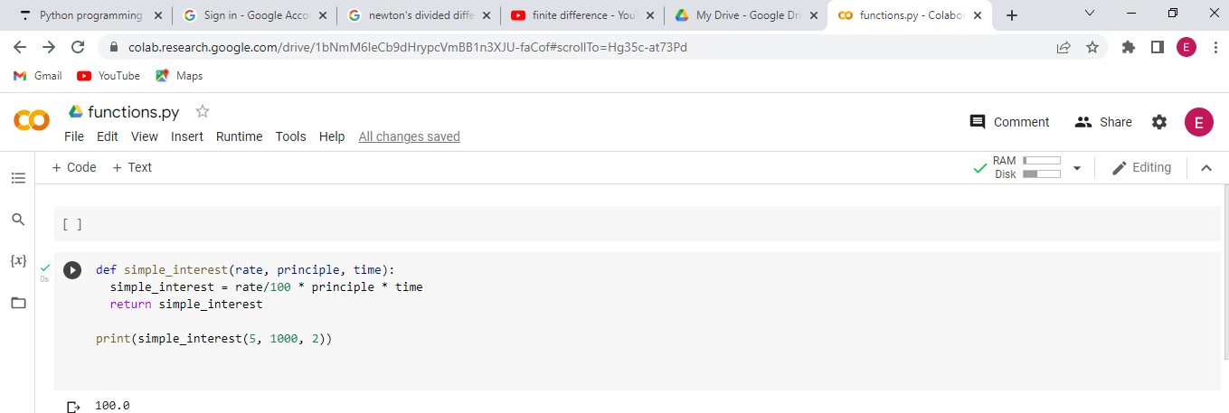

NB://The program should accepts three arguments and returns the simple interest accordingly

2.Write a Python program to sum  two given integers. However, if the sum is between 15 to 20 it will return 20 else it returns the actual sum

**Solution**

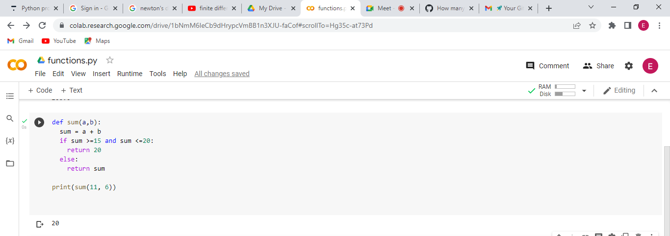

3.Write a function to calculate area and perimeter of a rectangle.

**Solution**

